Rain Prediction Model
Deployment and Responsible Reporting
Final Task 2 | Short final report | 20 September 2026
- Summary
Question | Answer
What is it? | A web page. You type today's weather for one of six cities (Gilgit, Islamabad, Karachi, Lahore, Peshawar, Quetta). It says Yes or No for rain tomorrow and shows the chance of rain in percent.
How does it work? | A Random Forest model learned from 31,779 days of weather records (2000 to 2024).
How good is it? | In the notebook test it was right 83.5% of the time. But a model that always says "no rain" is right 77.9% of the time on the same days, so the real gain is small.
Biggest weakness | It misses many rain days. It catches about 45% of rain days in the hardest test and about 66% in a fairer test. In Karachi it catches only about 19%.
Can I trust it? | Use it as a rough hint only. When it shows "unsure" (near 50%), treat it like a coin flip.
Do NOT use it for | Floods, travel safety, or any big decision. It is a student project, not an official forecast.
How will we watch it? | Every answer is saved. Each day we compare with what really happened. Weekly and monthly reports give alerts if scores drop or the inputs look strange.
What we need decided | (1) Is missing rain worse than a false alarm? If yes, we should lower the 50% cut-off. (2) Who will send the real rain results each day for monitoring?

2. What I built
I took the Random Forest from my notebook and made it ready to use. The project has these parts:
- Inference workflow. Every prediction follows 6 steps: receive, validate, build the missing columns, predict, decide Yes/No, and log.
- Web page and API. A Flask page with a simple form, two example buttons and clear messages. The same model can be called with JSON.
- Input checks. Bad input is stopped with a clear message. Unusual input gives a warning.
- Monitoring tools. A log of all predictions, a performance report, a drift check and alert rules.
- Tests and documents. 116 automatic tests, 9 browser checks, and a model card, monitoring plan and README.

Step | What happens | Example
1. Receive | Values come from the form or JSON | Islamabad, 2024-07-15, humidity 88, ...
2. Validate | Check every value | "Humidity must be between 1 and 100"
3. Build | Fill in the columns the user did not type | season, region, latitude, tavg, dew point
4. Predict | The Random Forest gives a probability | 73%
5. Decide | 50% or more means Yes | "Yes, rain is likely tomorrow"
6. Log | Save the request and answer | logs/predictions.csv

3. Decisions I made and why
Decision | Why
Keep the Random Forest | It beat the Decision Tree on accuracy, precision, recall and F1 (83.5% against 73%).
Train the final model on all rows | The notebook test never showed Quetta to the model. Training on all rows lets it know all 6 cities. The scores in this report come from models that were tested on days they had not seen.
Ask for fewer inputs | The model needs 23 columns. Users type 7 weather values, the city and date. The rest is filled in (season, region, average temperature, dew point). I tested this and accuracy changed by only 0.3 points.
Rain history is optional | Many people do not know the rain of the last 7 days. If left empty, I use the typical value for that city and month and show a warning. This changed accuracy by only 0.1 points in my test.
Errors and warnings are different | Impossible values (humidity 150%) stop the prediction. Possible but unusual values (45 C in Karachi) only give a warning.
Keep the 50% cut-off | It keeps the results the same as the notebook. The percent and a "how sure" sentence are always shown. Changing the cut-off is left to the stakeholders.
Report the score for each city | One average hides that Karachi is weak. I also compare every score with "always say no rain".
Save no personal data | The log keeps only city, date, weather numbers and the answer.

4. Results

4.1 Notebook test
First 80% of rows for training, last 20% for testing. Because the file is sorted by city, the test days are all of Quetta and the end of Peshawar.
Score | Decision Tree | Random Forest
Accuracy | 73% | 83.5%
Precision (weighted) | 75.0% | 82.2%
Recall (weighted) | 72.9% | 83.5%
F1 score (weighted) | 73.8% | 82.1%
Always say "no rain" | - | 77.9%
Rain days caught by the Random Forest | - | 45.0% (633 of 1,406)

What this means: the model is only 5.6 points better than a lazy guess, and it misses more than half of the rain days.
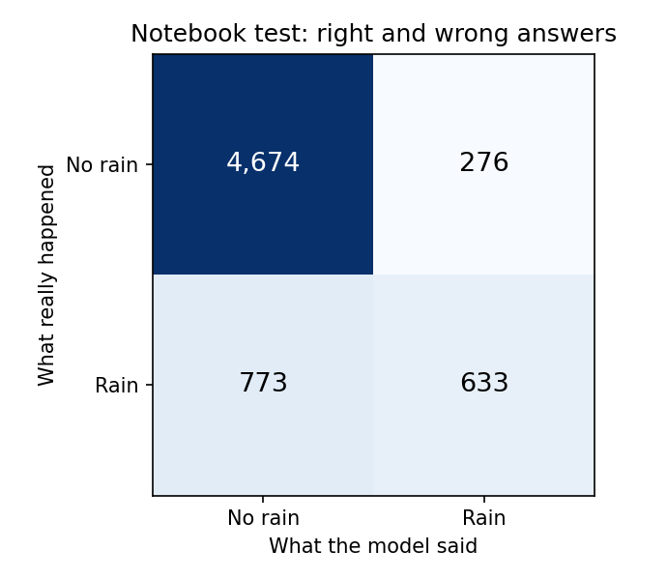  Right and wrong answers in the notebook test | 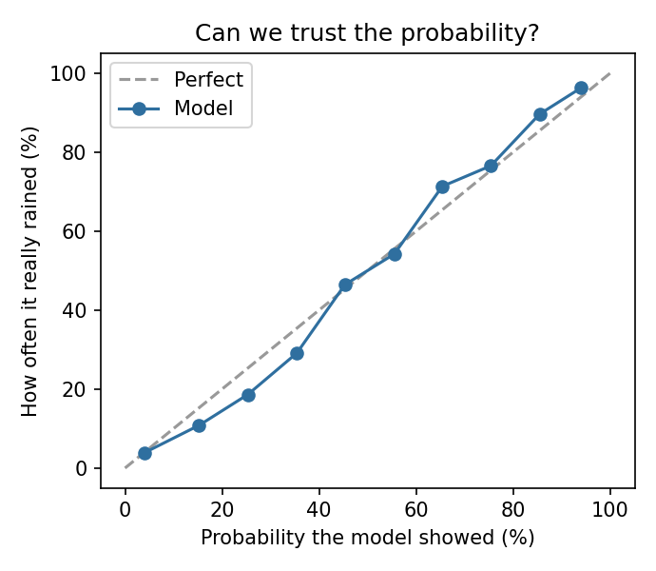  When the model says X%, how often does it rain?

4.2 Score for each city
Here I trained on the first 80% of each city and tested on the last 20% of each city. This is closer to real use: known cities and future days.
City | Always "no rain" | Model accuracy | Rain days caught | Right when it says rain
Gilgit | 37.7% | 82.3% | 83.5% | 87.5%
Islamabad | 59.4% | 74.9% | 65.8% | 70.4%
Karachi | 90.9% | 91.0% | 18.7% | 52.6%
Lahore | 63.4% | 81.5% | 69.3% | 77.7%
Peshawar | 68.2% | 78.8% | 61.5% | 68.5%
Quetta | 79.9% | 83.8% | 38.9% | 67.0%
All cities | 66.6% | 81.3% | 65.7% | 75.2%
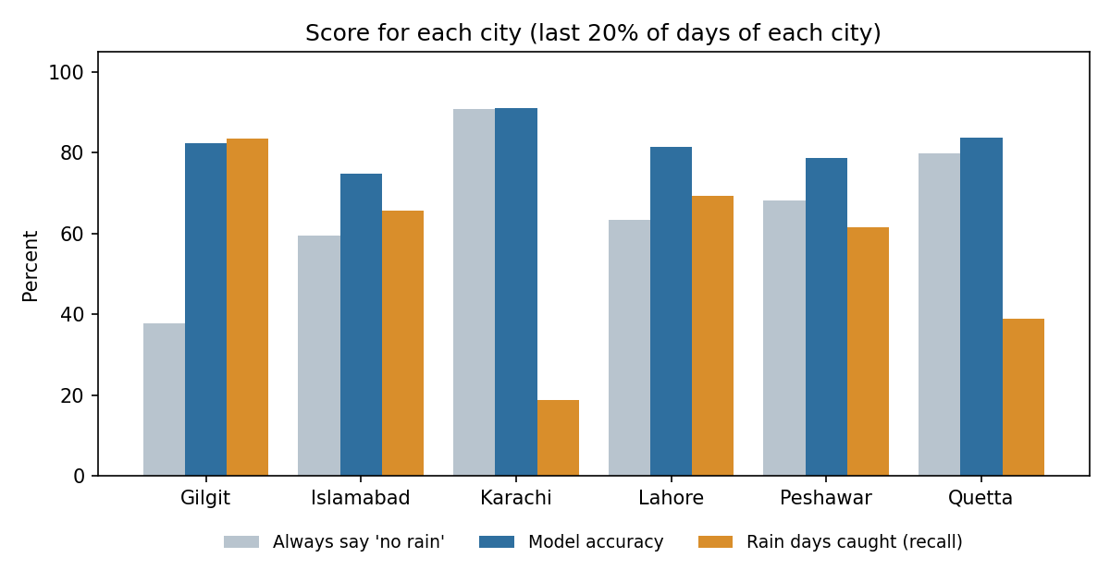
Model accuracy compared with always saying "no rain", and the share of rain days caught
What this means: the tool works well for Gilgit and Lahore, is average for Islamabad and Peshawar, and is weak for Karachi and Quetta, where rain is rare.

5. Testing and demo evidence
Test | Result | What it shows
Automatic tests (pytest) | 116 passed | Input checks, feature building, predictions, web page, API, monitoring, model files
Breaking the code on purpose | Tests failed | The tests really catch mistakes
Browser checks (Chromium) | 9 of 9 passed | Form, Yes and No answers, error messages, warnings, Enter key, phone screen
Reproduce notebook score | 83.50% | Same as the notebook
Common-sense test | Passed in 6 cities | A wet, cloudy day always gives a higher chance than a dry, clear day
Monitoring simulation | 0 alerts / 6 alerts | Normal inputs give no alerts; a pretend sensor problem gives 6

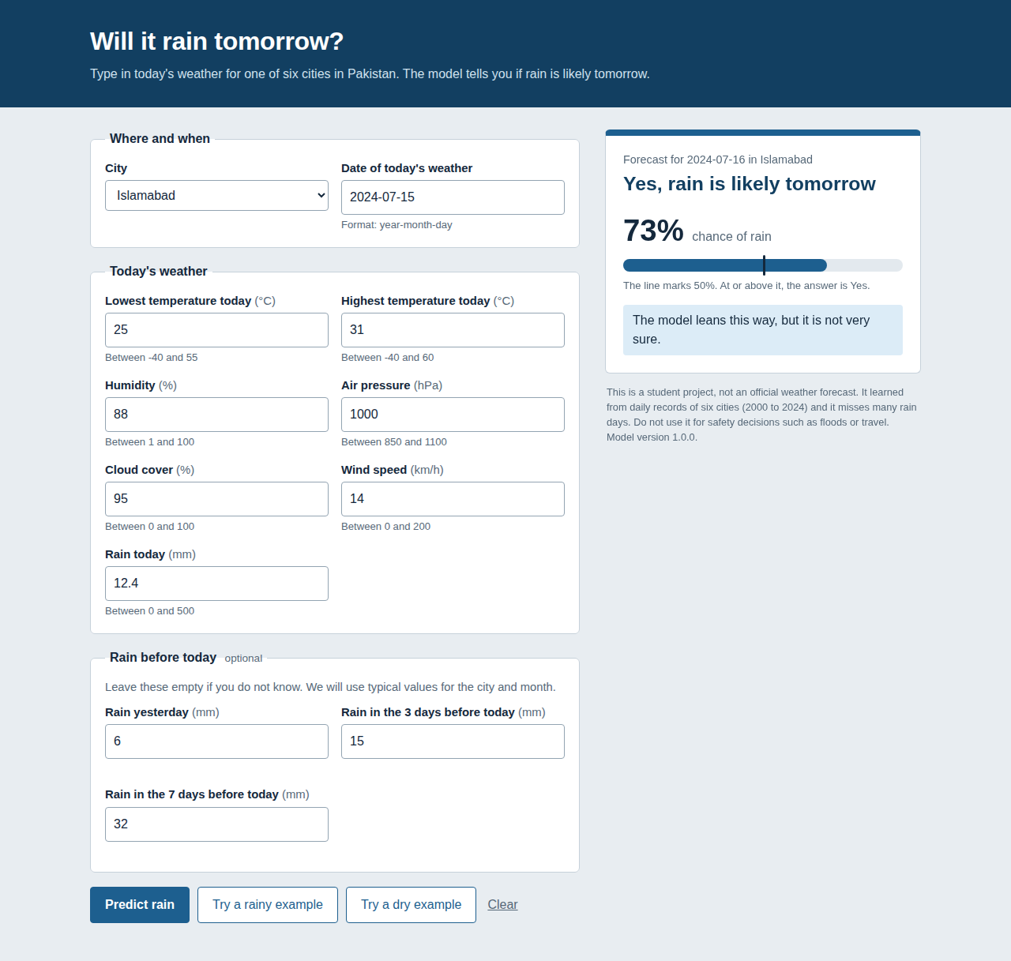  Rainy example: "Yes", 73% | 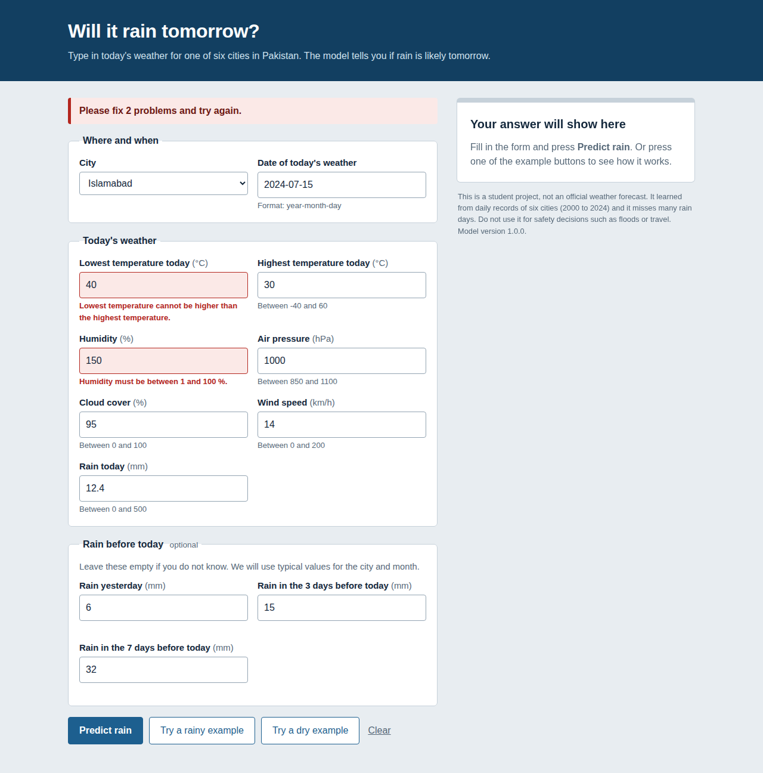  Impossible values are refused with a message
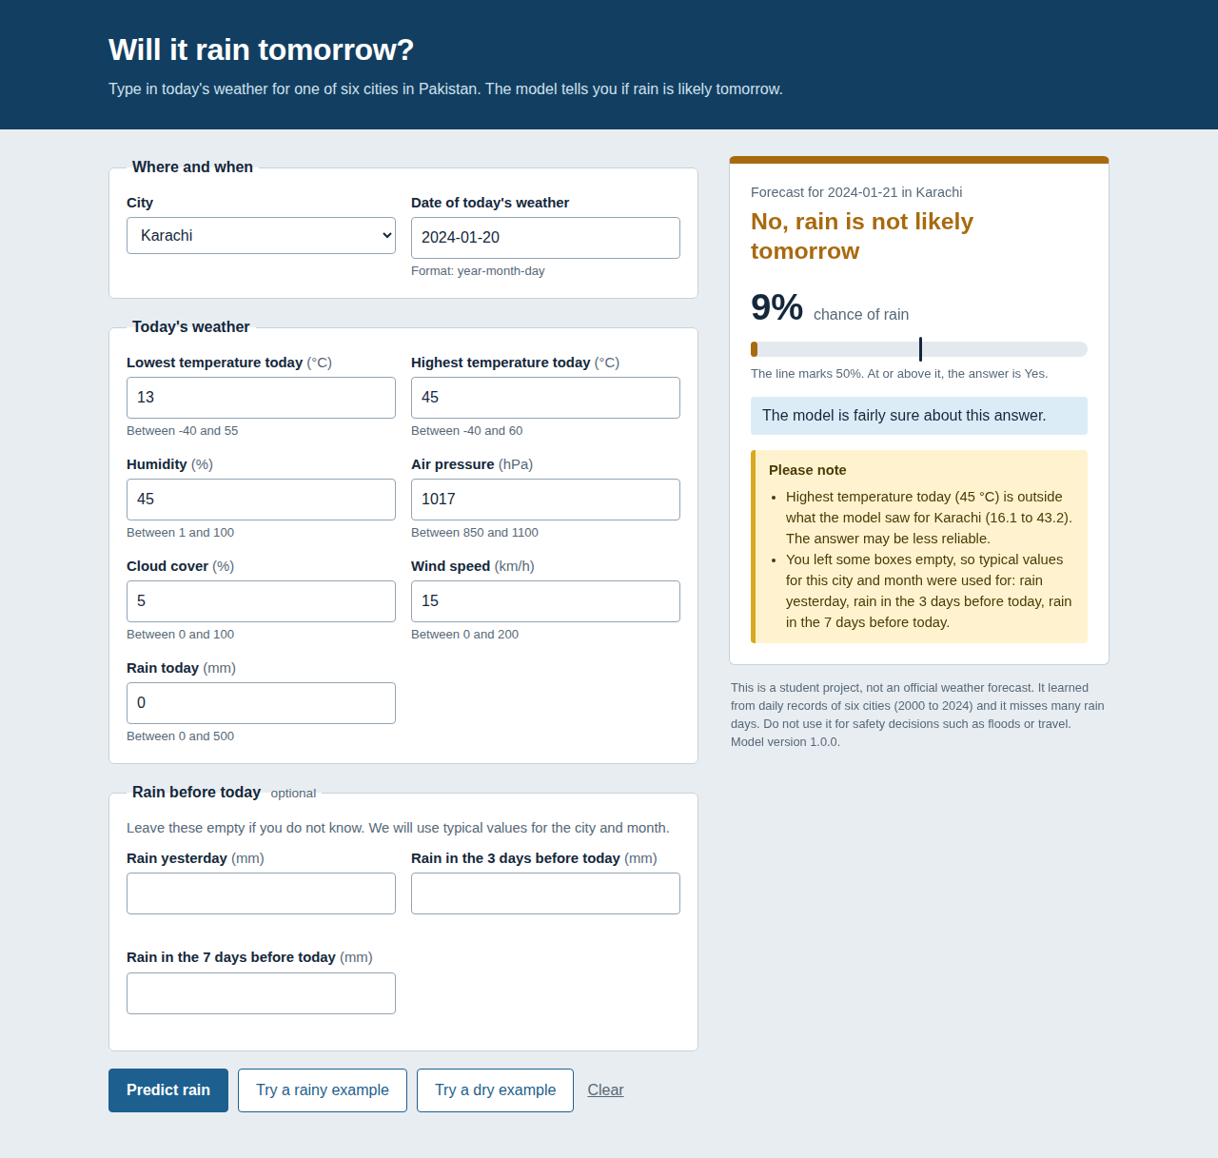  Unusual value and guessed rain history give warnings | 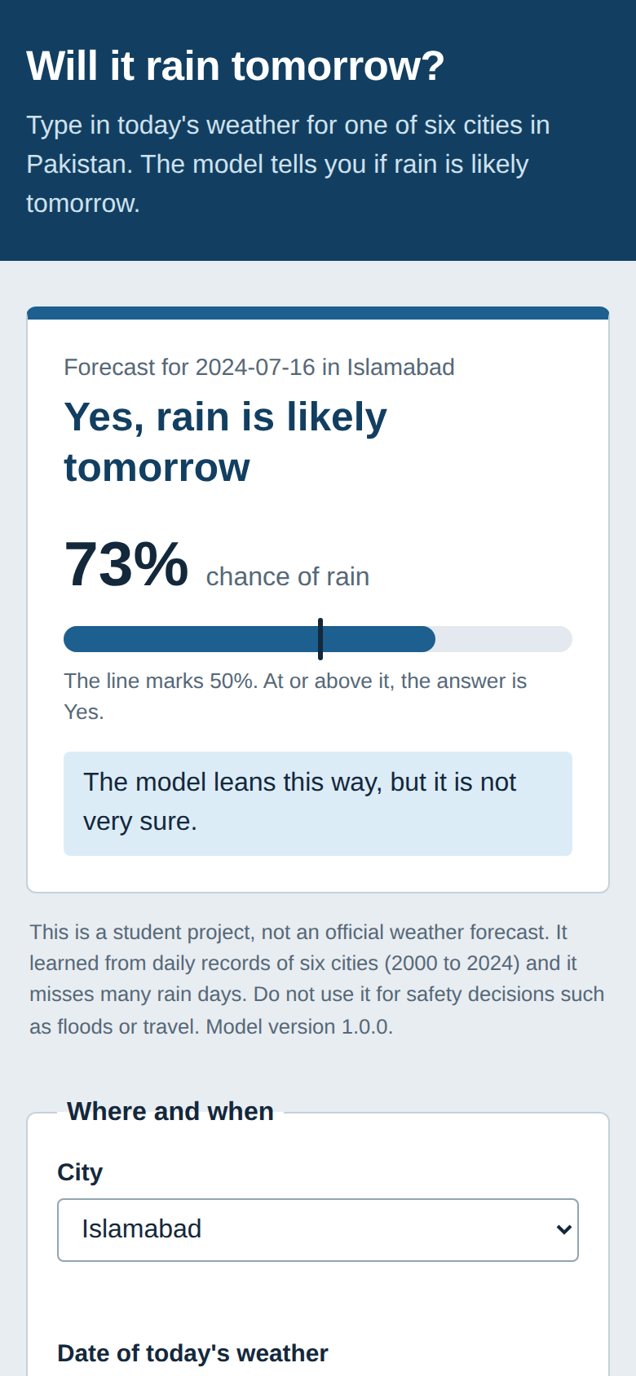  Phone view: the answer is on top

6. How to track performance after deployment
A model can slowly get worse. So we watch three things.
What | How | Alert when | How often
Is it still right? | Save the real rain of each day. Match it with the prediction made the day before. Look at accuracy, rain days caught, and each city. | Accuracy below 75%, not better than "always no", or rain days caught below 45% | Monthly (at least 100 matched days)
Are inputs changing? | Compare live values with training data for the same city and month. | Average moves more than 0.5 standard deviations, or over 5% of values outside the training range | Weekly
Is the system healthy? | Health check, speed and error counts | No answer 3 times, slower than 0.5 seconds, any server error | Every few minutes

Demo (simulation, not real live data). With normal inputs there were no alerts. When I pretended a sensor was wrong (temperature +6 C, humidity -25 points), accuracy fell only from 81.6% to 79.0%, which is easy to miss. But the drift check raised 6 alerts at once. So watching the inputs gives an early warning.
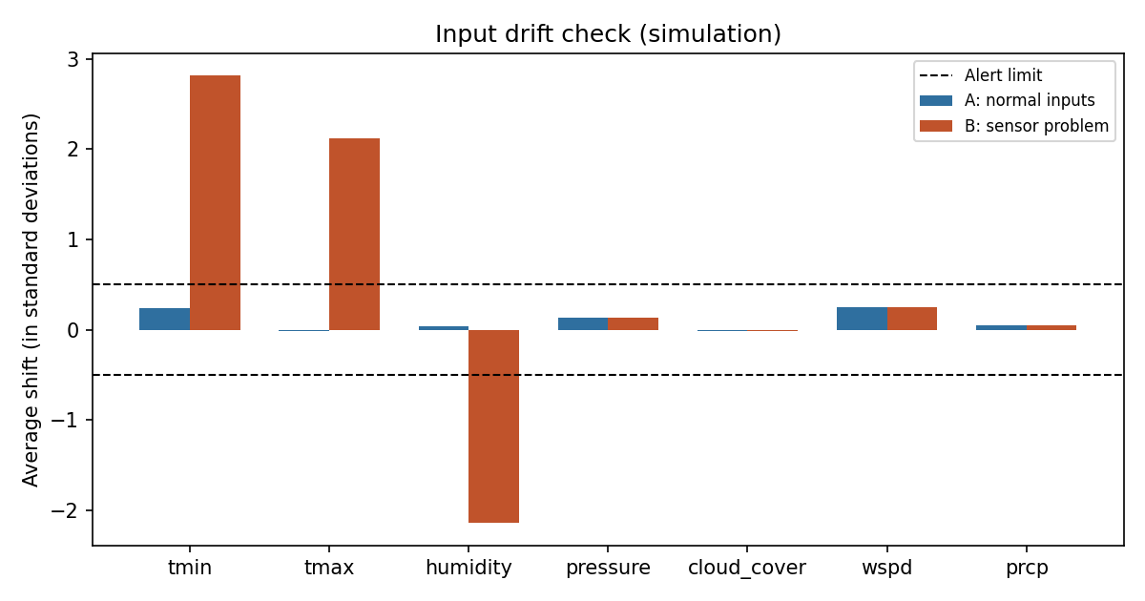
Input drift check (simulation). Bars beyond the dashed lines raise an alert
Retrain when: accuracy alerts for two months in a row, a drift alert that stays for a month, new data for Gilgit, Peshawar or Karachi (their data stops in 2011, 2013 and 2015), or a new city.

7. Limitations
- It is only a little better than guessing "no rain" in the notebook test, and it misses many rain days.
- Karachi: accuracy is 91.0%, but "always no rain" gives 90.9%. It catches only about 1 rain day in 5.
- The data is old. Gilgit ends in 2011, Peshawar in 2013 and Karachi in 2015.
- The model uses the year, which it has never seen for 2025 or 2026. It also uses day of the week, which has no real link to rain.
- It only uses today's measurements. It cannot see a storm that is coming, so it is weaker than an official forecast.
- Only six cities. Other places are refused.
- The answer is only as good as the numbers typed in. The page checks ranges but cannot know if a possible number is wrong.
- No real users and no heavy-traffic test yet. The Flask server is for a demo.

8. Fairness and risk
- Places are treated differently. People in Karachi and Quetta get worse answers than people in Gilgit. I show the score per city and a "how sure" sentence so nobody thinks all cities are equal.
- Unequal data. Islamabad has 25 years of data and Lahore only 9. Big cities are learned better.
- Who can use it. The form needs pressure, humidity and cloud cover. People without instruments cannot fill it in.
- Missed rain versus false alarm. A missed rain day is usually worse (someone is not ready). With a 40% cut-off the model catches 78% of rain days instead of 66%, but it is right less often when it says rain (68% instead of 75%). The stakeholders should choose.
- Wrong use. Someone might treat it as an official forecast. Every page says it is a student project and not for safety decisions.
- Privacy. No names or exact locations are saved.

9. Challenges
- The notebook score looked good (83.5%) but hid two things: Quetta was never in training, and "always no rain" already scores 77.9%. I had to add a second, fairer test to see the real picture.
- The model needs 23 columns but users should not type them all. I filled in 9 columns from the date and city, and calculated 3 more. Then I tested that this does not hurt the model.
- There is no real live data yet, so I could not test monitoring on real traffic. I used a clearly labelled simulation.
- The first prediction took about 1 second because the model was loading. I now load it once when the app starts (later predictions take about 10 ms).
- I found a small mistake in my notebook: cell 21 prints the Random Forest accuracy under the Decision Tree heading. The comparison in cell 24 is correct. I left the notebook as it was and wrote this in the README.

10. Future improvements
- Get newer data (especially 2016 to 2026 for Gilgit, Peshawar and Karachi) and retrain.
- Remove year and day of the week, then test again to see if scores improve.
- Test a lower cut-off, or a different cut-off for each city, on new data.
- Try other models (for example gradient boosting) using the same fair, time-based tests.
- Add forecast or satellite data so the model can see storms that are coming.
- Fill in today's weather and the rain history automatically from a weather service.
- Add more cities and test with real users.
- Deploy properly (production server, HTTPS, login if needed) and run the monitoring reports automatically.

11. Where to find things
File or folder | What is inside
README.md | How to install and run, project map
app/ and src/ | Web page and the code (validation, prediction, monitoring)
docs/MODEL_CARD.md | Limits, fairness and risk in detail
docs/MONITORING_PLAN.md | How performance is tracked after deployment
docs/INFERENCE_AND_VALIDATION.md | The workflow, the input rules and API examples
docs/TEST_EVIDENCE.md and docs/screenshots/ | Test results and pictures
reports/ | Score tables, charts, monitoring demo output

